**LAB # 04**

**Task # 1: Create an application which can display a Toast message by pressing a button.**

**Solution:**

**Design:**

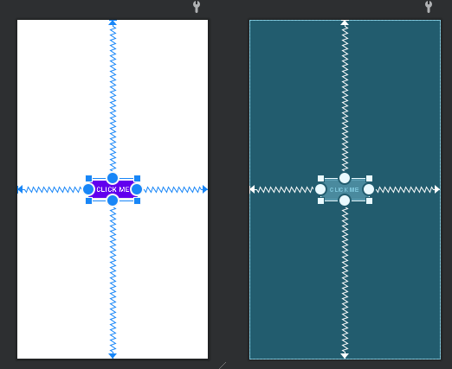

**Activity Code:**

public class MainActivity extends AppCompatActivity {

private Button btn;

@Override

protected void onCreate(Bundle savedInstanceState) {

super.onCreate(savedInstanceState);

setContentView(R.layout.activity_main);

btn=findViewById(R.id.button);

btn.setOnClickListener(new View.OnClickListener() {

@Override

public void onClick(View view) {

Toast.makeText(MainActivity.this, "Click me", Toast.LENGTH_SHORT).show();

}

});}}

**Output:**

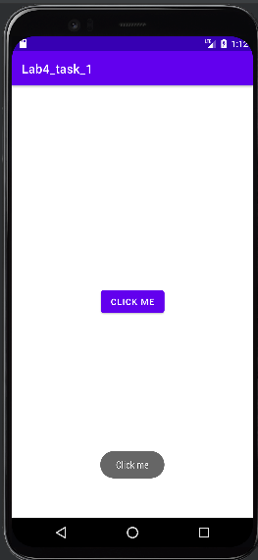

**Task # 2: Create an application having three buttons. Bind those buttons with the same callback method. On pressing any button, identify which button was pressed.**

**Solution:**

**Design:**

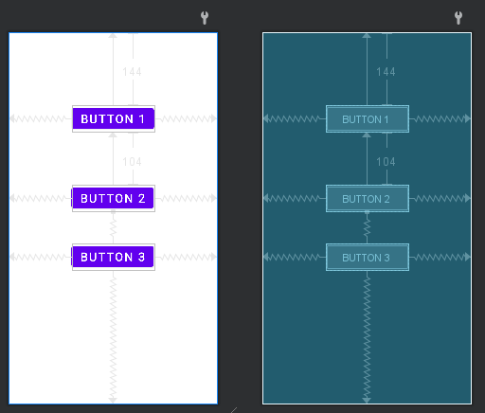

**Code:**

public class MainActivity extends AppCompatActivity {

private Button btn;

private Button btn2;

private Button btn3;

@Override

protected void onCreate(Bundle savedInstanceState) {

super.onCreate(savedInstanceState);

setContentView(R.layout.activity_main);

btn=findViewById(R.id.button);

btn2=findViewById(R.id.button2);

btn3=findViewById(R.id.button3);

btn.setOnClickListener(new View.OnClickListener() {

@Override

public void onClick(View view) {

Toast.makeText(MainActivity.this, ""+btn.getText(), Toast.LENGTH_SHORT).show();

}

});

btn2.setOnClickListener(new View.OnClickListener() {

@Override

public void onClick(View view) {

Toast.makeText(MainActivity.this, ""+btn2.getText(), Toast.LENGTH_SHORT).show();

}

});

btn3.setOnClickListener(new View.OnClickListener() {

@Override

public void onClick(View view) {

Toast.makeText(MainActivity.this, ""+btn3.getText(), Toast.LENGTH_SHORT).show();

}

});

}

}

**Output:**

|  |  |  |
| --- | --- | --- |
|  |  |  |

**Task # 3: Create an application which takes a string message from user and create a toast of it on pressing button.**

**Solution:**

**Design:**

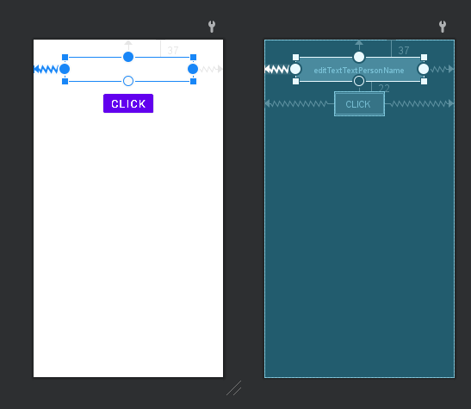

**Code:**

public class MainActivity extends AppCompatActivity {

private Button btn;

private EditText txt;

@SuppressLint("MissingInflatedId")

@Override

protected void onCreate(Bundle savedInstanceState) {

super.onCreate(savedInstanceState);

setContentView(R.layout.activity_main);

btn=findViewById(R.id.button4);

txt=findViewById(R.id.editTextTextPersonName);

btn.setOnClickListener(new View.OnClickListener() {

@Override

public void onClick(View view) {

Toast.makeText(MainActivity.this, ""+txt.getText(), Toast.LENGTH_SHORT).show();

}

}); }

}

**Output:**

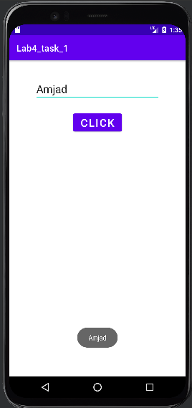

**Task # 4: Create a calculator application for two integers.**

**Solution:**

**Design:**

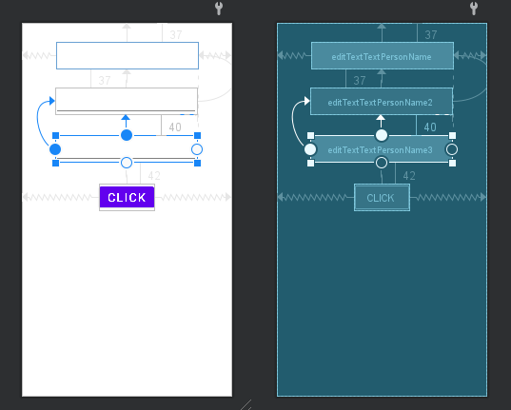

**Code:**

public class MainActivity extends AppCompatActivity {

private Button btn;

private EditText txt;

private EditText txt2;

private EditText txt3;

@SuppressLint("MissingInflatedId")

@Override

protected void onCreate(Bundle savedInstanceState) {

super.onCreate(savedInstanceState);

setContentView(R.layout.activity_main);

btn=findViewById(R.id.button4);

txt=findViewById(R.id.editTextTextPersonName);

txt2=findViewById(R.id.editTextTextPersonName2);

txt3=findViewById(R.id.editTextTextPersonName3);

btn.setOnClickListener(new View.OnClickListener() {

@Override

public void onClick(View view) {

btn.setOnClickListener(new View.OnClickListener() {

@Override

public void onClick(View view) {

int num1=Integer.parseInt(""+txt.getText());

int num2=Integer.parseInt(""+txt2.getText());

int res=num1+num2;

txt3.setText(""+res);

} }); }

});

}

}

**Output:**

